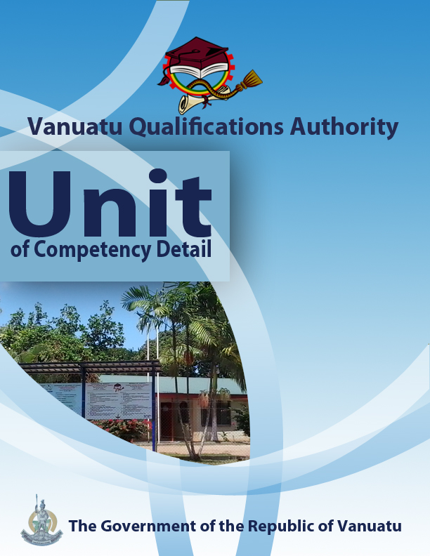

CGHR0116
Demonstrate knowledge of hazard risks
Level | 1
Credit | 6
Unit Descriptor | This unit describes the performance outcomes, skills and knowledge required to demonstrate the impacts of natural and human-made hazards on local communities in Vanuatu, and their management.
Pre-requisite | Nil
Co – requisite | Nil
ELEMENT  - Identify the most common hazards found in Vanuatu.  - Illustrate how a hazard can become a disaster.  - Distinguish between different types of hazard.  - Identify community responsibility for reducing disaster risks.  - Identify hazard risks in a local community. | PERFORMANCE CRITERIA  - Natural disaster events occurring in the local area /Vanuatu are identified.  - The impacts of different types of disaster are stated  - Possible responses to disaster events are stated.  - The terms hazard, emergency and disaster are differentiated.  - Examples are given of how a natural hazard risk can become a disaster.  - Natural and human-made hazards are differentiated.  - Hydro-meteorological hazards affecting Vanuatu are identified.  - Geological hazards affecting Vanuatu are identified.  - Biological and other natural hazards occurring in the Pacific are identified.  - Human-made hazards occurring in the Pacific are identified.  - The natural and human factors leading to recent disaster events are stated.  - The link between disaster risk reduction and the speed of onset of natural hazards is demonstrated.  - The responsibility of individuals and communities for reducing disaster risks and increasing resilience is demonstrated.  - There is clear identification of features of a local community that are at risk from natural and human-made hazards.  - Explanations are given for the features of a local community that are at risk from natural and human-made hazards.
KEY COMPETENCIES/EMPLOYABILITY SKILLS AND EXAMPLES OF APPLICATION

Required skills* | Example of application
Initiative | Adapting to new situations • developing a strategic long-term vision • being creative • identifying opportunities not obvious to others • translating ideas into action • generating a range of options • initiating innovative solutions  - Initiate and carry out research into types of hazards, their effects on humans and the environment, and the community response.
Communication  establishing and using networks | Verbal or non-verbal that includes: • speaking clearly and directly • writing to the needs of the audience • understanding the needs of internal and external parties • persuading effectively •  - Present information both visually (using hand-drawn illustrations and technology) and verbally to individuals and groups on community responsibilities for reducing disaster risks and responding to the impact of climate change.  - Use basic drawing/mapping skills such as direction, scale, key, etc.
Teamwork | Working with people of different ages, gender, race, religion or political persuasion • working as an individual and as a member of a team • knowing how to define a role as part of a team • applying teamwork skills to a range of situations  - Cooperate in a small group to produce a hazard and risk map and description of a community, identifying areas, assets and people at risk.
Information & Communication Technology | Having a range of basic IT skills • applying IT as a management tool • using IT to organise data • being willing to learn new IT skills • having the occupational health and safety knowledge to apply technology • having the appropriate physical capacity  - Use phones, email, social media to access information on hazards and disasters.
Problem solving | Developing creative, innovative solutions • developing practical solutions • showing independence and initiative in identifying problems solving problems in teams • applying a range of strategies to problem solving • applying problem-solving strategies across a range of areas  - Analyse features of a village to determine areas that are at risk from natural and man-made hazards.
Self-management | Having a personal vision and goals • evaluating and monitoring own performance • having knowledge and confidence in own ideas and vision • articulating own ideas and vision • taking responsibility  - Reflect on knowledge and understanding of disasters and community life in the local area.
Planning | Managing time and priorities – setting timelines, coordinating tasks • being resourceful • taking initiative and making decisions • establishing clear project goals and deliverables • allocating people and resources to tasks • participating in continuous improvement and planning • developing a vision and a proactive plan to accompany it  - Plan the collection of information from a community in order to determine areas at risk from natural and man-made hazards.
Learning (gaining new skills and knowledge) | Managing your own learning using a range of learning options suited to the individual learning style– mentoring, peer support, networking; • having enthusiasm for ongoing learning; • being willing to learn in any setting• being open to new ideas and techniques • being prepared to invest time and effort in learning new skills  - Participate willingly in group discussions to share knowledge, and engage in planning to use new knowledge and skills within communities to assist them to better prepare for, and manage, disaster risks.
GESI (Gender Equity and Social Inclusion) | Valuing and supporting women and disadvantaged persons and equal opportunity for all in workplaces and communities • mentoring younger people • valuing and respecting older people • having respect for different cultural, social, religious and political values  - Ensure that discussions and field surveys in the communities are inclusive of both male and female perspectives on disasters and disaster risk management.
* as per Provincial Skills Plan

Required knowledge
- Knowledge and experience of natural hazards and disasters in Vanuatu
- First-hand knowledge of a local village or community
- Knowledge of local traditional wisdom and cultural practices

RANGE STATEMENT

The range statement relates to the unit of competency as a whole. It allows for different work environments and situations that may affect performance. Bold italicised wording, if used in the performance criteria, is detailed below.

Biological and other natural hazards include:
- pests, diseases and pollution

Disaster refers to:
- a situation when the impacts of a natural hazard are greater than the community’s ability to respond and get back to normal.

Emergency refers to:
- a loss or difficulty that a community is able to handle using its own resources.

Features of a local community include areas, assets and people:
- specific locations, members or sectors of the community that are exposed to greater damage or injury from hazards, for example, coastal areas, steep slopes, water wells, elderly and disabled people.

Geological hazards include:
- earthquakes, volcanic eruptions and tsunamis

Hazard refers to:
- something that may cause disruption or damage to life, property and/or the environment.

Hazards and disaster events may include:
- earthquakes, tsunamis, volcanic eruptions, tropical cyclones, landslides, floods, king tides, drought, El Niño and La Niña, coastal erosion, fire, outbreaks of pests and diseases, pollution
Human-made hazards include:
- those caused by people intentionally or by accident, and those resulting from problems in human-made systems or infrastructures.

Hydro-meteorological hazards include:
- cyclones, tropical storms, heavy rain, river floods, coastal inundation, erosion, landslides, strong winds and droughts

Impacts of different types of disaster refers to:
- both short-term and long-term effects of various kinds of disaster

Natural and human factors leading to recent disaster events include:
- natural and human-made causes of disasters

Resilience includes:
- ways in which communities reduce the negative impacts of natural hazards and are able to maintain sustainable way of life through stress or change.

Responses to disaster events may include:
- actions (or lack of actions) by individuals, communities, schools, private businesses, non-government organizations, faith-based organizations, police, health centres, provincial governments and the national government to help minimize damage to property and the environment, injuries or loss of life of people and animals.

Speed of onset of a natural hazard refers to:
- the arrival time of a natural hazard, ranging from very slow to very rapid.

EVIDENCE GUIDE  The evidence guide provides advice on assessment and must be read in conjunction with the performance criteria, required skills and knowledge, range statement and the Assessment Guidelines for the Training Package.  Critical aspects for assessment and evidence required to demonstrate competency in this unit  Evidence of the following knowledge, skills and attributes is essential:  - Knowledge and understanding of hazards and disasters  - Skill to identify disaster risks in a local community  - Communication skills to develop individual and community awareness of hazards and disaster risk reduction. | Context of Assessment  - Assessment of underpinning knowledge and communication of ideas can be done in the classroom through observation and discussion.  - Assessment of the hazard risk map can be done in the field or in the classroom.  Resource Implications  Assessment process and resources must ensure:  - Physical access to communities to observe communications and/or collection of information and data  - Checklists for the learner and assessor to guide community activities, communications and observations
Assessment Methods

Assessment methods must be chosen to ensure that knowledge of hazard risks can be practically demonstrated. Methods must include assessment of knowledge as well as assessment of practical skills. Assessment of this unit may be done in conjunction with assessment of other units of competency in the course.

Some of the following methods are appropriate for this unit:
- Direct oral questioning combined with third party workplace or community reports of knowledge and performance by the learner
- Direct observation during community contact (may be undertaken during field visits and/or using technology such as phone/video)
- Review of any written documentation evidencing knowledge and skills (maps, workbook activities)
- Oral and/or written reflections by learners
- Written holistic/summative assessment

