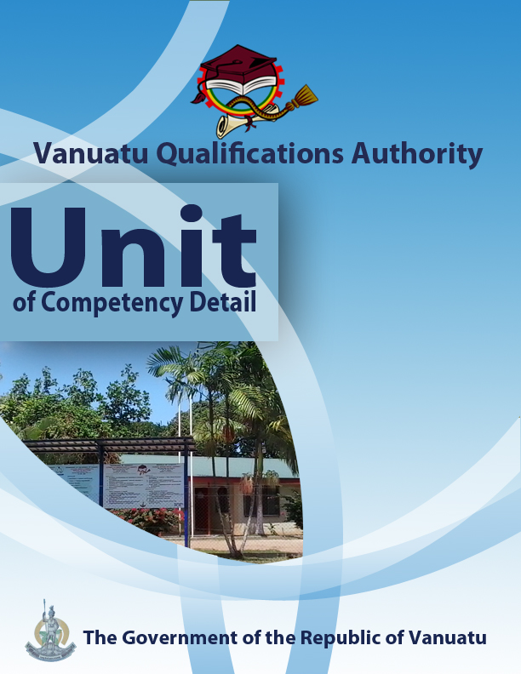

CGCK0216

Demonstrate knowledge of climate

Level | 1
Credit | 3
Unit Descriptor | This unit describes the performance outcomes, skills and knowledge required to explain the features of weather and climate in Vanuatu.
Pre-requisite | CGHR0116
Co – requisite | Nil
ELEMENT  - Differentiate between weather and climate.  - Differentiate between climate variability and climate change.  - Demonstrate the seasonal changes in Vanuatu’s temperature and rainfall.  - Demonstrate processes in the water cycle.  - Demonstrate factors that cause variations in climate within Vanuatu. | PERFORMANCE CRITERIA  - The main elements of weather and climate are stated.  - The difference between weather and climate is stated.  - The earth’s principal climatic zones are identified.  - The difference between climate variability and climate change is clarified.  - Graphs are used to demonstrate the difference between climate variability and climate change.  - Climographs are used to show how Vanuatu’s temperature and rainfall change during the year.  - Links between temperature, humidity and evaporation are demonstrated.  - Processes in the water cycle are identified.  - Demonstration is given of ways in which latitude and altitude cause differences in climate from place to place in Vanuatu  - Areas in Vanuatu that are more vulnerable to drought and floods are identified.
KEY COMPETENCIES/EMPLOYABILITY SKILLS AND EXAMPLES OF APPLICATION

Required skills | Example of application
Initiative | Adapting to new situations • developing a strategic long-term vision • being creative • identifying opportunities not obvious to others • translating ideas into action • generating a range of options • initiating innovative solutions  - Initiate and carry out enquiries and independent research into weather and climate in Vanuatu, and their variations.
Communication | Verbal or non-verbal that includes: • speaking clearly and directly • writing to the needs of the audience • understanding the needs of internal and external parties • persuading effectively • establishing and using networks  - Present information both visually (using hand-drawn illustrations and technology) and verbally to explain climatic features in Vanuatu.
Teamwork | Working with people of different ages, gender, race, religion or political persuasion • working as an individual and as a member of a team • knowing how to define a role as part of a team • applying teamwork skills to a range of situations  - Undertake discussions and activities in pairs and groups regarding findings related to learning about world climatic zones and the water cycle  - Cooperate in a small group to draw a map of an island in Vanuatu showing areas liable to drought and flooding.
Information & Communication Technology | Having a range of basic IT skills • applying IT as a management tool • using IT to organise data • being willing to learn new IT skills • having the occupational health and safety knowledge to apply technology • having the appropriate physical capacity  - Use the internet and print materials to discover examples of features of weather and climate in Vanuatu and the Pacific.  - Use phones, email and social media to access information on weather and climate.  - Use computer applications to construct climatic graphs, maps and diagrams.
Problem solving | Developing creative, innovative solutions • developing practical solutions • showing independence and initiative in identifying problems solving problems in teams • applying a range of strategies to problem solving • applying problem-solving strategies across a range of areas  - Determine areas of Vanuatu that have a greater likelihood of flooding and drought.
Self-management | Having a personal vision and goals • evaluating and monitoring own performance • having knowledge and confidence in own ideas and vision • articulating own ideas and vision • taking responsibility  - Reflect on knowledge and understanding of weather and climate and their variations.
Planning | Managing time and priorities – setting timelines, coordinating tasks • being resourceful • taking initiative and making decisions • establishing clear project goals and deliverables • allocating people and resources to tasks • participating in continuous improvement and planning • developing a vision and a proactive plan to accompany it  - Plan, collect and collate information about weather in the local area.
Learning (gaining new skills and knowledge) | Managing your own learning using a range of learning options suited to the individual learning style– mentoring, peer support, networking; • having enthusiasm for ongoing learning; • being willing to learn in any setting• being open to new ideas and techniques • being prepared to invest time and effort in learning new skills  - Participate in group discussions to share knowledge and gain new skills and learning in relation to weather and climate in Vanuatu.
GESI (Gender Equity and Social Inclusion) | Valuing and supporting women and disadvantaged persons and equal opportunity for all in workplaces and communities • mentoring younger people • valuing and respecting older people • having respect for different cultural, social, religious and political values  - Ensure that discussions in the classroom and in communities are inclusive of both male and female perspectives on weather, climate and their variations.
* as per Provincial Skills Plan

Required knowledge
- Knowledge and experience of local weather, climate and climatic variations.
- First-hand knowledge of a local village or community
- Knowledge of local traditional wisdom and cultural practices

RANGE STATEMENT

The range statement relates to the unit of competency as a whole. It allows for different work environments and situations that may affect performance. Bold italicised wording, if used in the performance criteria, is detailed below.

Climate change refers to:
- changes in climate, measured statistically, that persist for an extended period of time, usually for several decades, either due to natural variability or as a result of human activity.

Climate variability refers to:
- the way that warm and cold, wet and dry seasons are not the same from one year to the next.

Climatic zones are:
- major belts around the earth classified by their temperature. We can distinguish between polar, temperate, sub-tropical and tropical zones.

Climographs (climatic graphs) are usually:
- graphs that show average monthly statistics of temperature and rainfall over a period of one year.

Elements of weather and climate may include:
- temperature, precipitation (rainfall), humidity, wind direction, wind speed, cloud cover, cloud type, hours of sunshine, intensity of sunshine (radiation) and atmospheric pressure.

Humidity refers to:
- the water vapour content of the air. It includes absolute humidity and relative humidity.

Latitude and altitude are:
- two of the factors affecting world climates. Latitude refers to distance from the Equator, and altitude refers to height above mean sea level.

The water cycle refers to:
- a set of pathways in which water moves around and changes from one state to another. It is driven by solar energy and includes the processes of evapo-transpiration, condensation, precipitation, run-off and underground flow.

EVIDENCE GUIDE  The evidence guide provides advice on assessment and must be read in conjunction with the performance criteria, required skills and knowledge, range statement and the Assessment Guidelines for the Training Package.  Critical aspects for assessment and evidence required to demonstrate competency in this unit  Evidence of the following knowledge, skills and attributes is essential:  - Understanding of the features and elements of weather, climate, and climatic variations in Vanuatu.  - Communication skills to develop individual and community awareness of the features of weather and climate, and their variations. | Context of Assessment  - Assessment of underpinning knowledge and communication of ideas can be done in the classroom through observation and discussion.  - Assessment of awareness talks on the water cycle and the difference between weather and climate can be done in the field or in the classroom.  Resource Implications  Assessment process and resources must ensure:  - Physical access to communities to observe communications and/or collection of information and data  - Checklists for the learner and assessor to guide community activities, communications and observations
Assessment Methods

Assessment methods must be chosen to ensure that knowledge of weather, climate and climatic variations can be practically demonstrated. Methods must include assessment of knowledge as well as of practical skills, and may be done in conjunction with assessment of other units of competency. Allowance should be made for participants with disabilities. Some of the following examples are appropriate:
- Direct oral questioning combined with third party workplace or community reports of knowledge and performance by the learner
- Direct observation during community contact (may be undertaken during field visits and/or using technology such as phone/video)
- Review of any written documentation evidencing knowledge and skills (maps, workbook activities)
- Oral and/or written reflections by learners
- Written holistic/summative assessment

