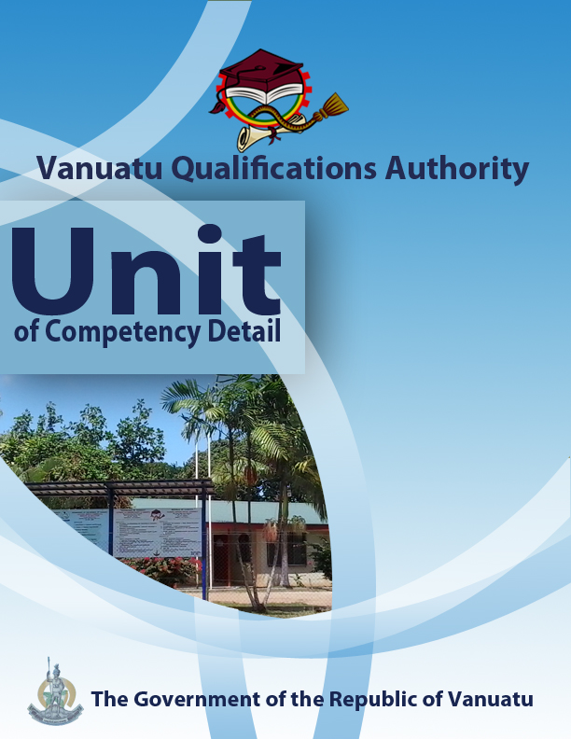

CGCV0316

Demonstrate knowledge of climatic variations

Level | 1
Credit | 3
Unit Descriptor | This unit describes the performance outcomes, skills and knowledge required to explain the features of climate variability and climate change in Vanuatu.
Pre-requisite | CGHR0116, CGCK0216
Co – requisite | Nil
ELEMENT  - Demonstrate the key drivers that control climate variability in the tropical Pacific.  - Illustrate the main features of a tropical cyclone and its associated weather.  - Demonstrate long-term climatic change in Vanuatu | PERFORMANCE CRITERIA  - Knowledge of convergence zones and climate drivers is demonstrated.  - Understanding of El Niño and La Niña periods is demonstrated.  - A diagram of a tropical cyclone in the southern hemisphere is drawn.  - Features of the weather associated with a tropical cyclone are demonstrated.  - Graphical data is used to show that key climate indicators are changing in Vanuatu.
KEY COMPETENCIES/EMPLOYABILITY SKILLS AND EXAMPLES OF APPLICATION

Required skills | Example of application
Initiative | Adapting to new situations • developing a strategic long-term vision • being creative • identifying opportunities not obvious to others • translating ideas into action • generating a range of options • initiating innovative solutions  - Initiate and carry out enquiries and independent research into variations in weather and climate in Vanuatu, and their effects.
Communication | Verbal or non-verbal that includes: • speaking clearly and directly • writing to the needs of the audience • understanding the needs of internal and external parties • persuading effectively • establishing and using networks  - Present information both visually (using hand-drawn illustrations and technology) and verbally to explain climatic variability and climate change in Vanuatu.  - Communicate personal experiences which demonstrate an understanding of local climatic variations and their effects.
Teamwork | Working with people of different ages, gender, race, religion or political persuasion • working as an individual and as a member of a team • knowing how to define a role as part of a team • applying teamwork skills to a range of situations  - Undertake discussions and activities in pairs and groups regarding learning on climate variability and climate change.  - Cooperate in a small group to present graphical information on climatic variations in Vanuatu.
Information & Communication Technology | Having a range of basic IT skills • applying IT as a management tool • using IT to organise data • being willing to learn new IT skills • having the occupational health and safety knowledge to apply technology • having the appropriate physical capacity  - Use the internet and print materials to discover examples of variations in weather and climate in Vanuatu and the Pacific region.  - Use phones, email and social media to access information on climate and its variations.  - Use computer applications to construct climatic graphs, maps and diagrams.
Problem solving | Developing creative, innovative solutions • developing practical solutions • showing independence and initiative in identifying problems solving problems in teams • applying a range of strategies to problem solving • applying problem-solving strategies across a range of areas  - Determine areas of Vanuatu that have a greater likelihood of flooding and drought as a result of climate change and El Nino and La Nino periods  - Apply knowledge of tropical cyclones to assess the changes in weather that may occur as a cyclone approaches.
Self-management | Having a personal vision and goals • evaluating and monitoring own performance • having knowledge and confidence in own ideas and vision • articulating own ideas and vision • taking responsibility  - Reflect on knowledge and understanding of climate and its variations and the effects of these variations on communities in the local region.
Planning | Managing time and priorities – setting timelines, coordinating tasks • being resourceful • taking initiative and making decisions • establishing clear project goals and deliverables • allocating people and resources to tasks • participating in continuous improvement and planning • developing a vision and a proactive plan to accompany it  - Plan, collect and collate information from documents and oral discussions in order to make decisions about local issues affected by climatic variability and climate change.
Learning (gaining new skills and knowledge) | Managing your own learning using a range of learning options suited to the individual learning style– mentoring, peer support, networking; • having enthusiasm for ongoing learning; • being willing to learn in any setting• being open to new ideas and techniques • being prepared to invest time and effort in learning new skills  - Participate in group discussions to share knowledge and gain new skills and learning that will help communities to prepare for climate change.
GESI (Gender Equity and Social Inclusion) | Valuing and supporting women and disadvantaged persons and equal opportunity for all in workplaces and communities • mentoring younger people • valuing and respecting older people • having respect for different cultural, social, religious and political values  - Ensure that discussions in the communities are inclusive of both male and female perspectives on climate variability and climate change.
* as per Provincial Skills Plan

Required knowledge
- Knowledge and experience of local weather, climate and climatic variations.
- First-hand knowledge of a local village or community
- Knowledge of local traditional wisdom and cultural practices

RANGE STATEMENT
The range statement relates to the unit of competency as a whole. It allows for different work environments and situations that may affect performance. Bold italicised wording, if used in the performance criteria, is detailed below.

A tropical cyclone in the Southern Hemisphere refers to:
- a moving body of air with low pressure, in-blowing winds and heavy rainfall, found south of the Equator. The air circulates in a clockwise direction.

Climate change refers to:
- changes in climate, measured statistically, that persist for an extended period of time, usually for several decades, either due to natural variability or as a result of human activity.

Climate drivers are:
- factors that control the climate (and its variability) in a region.

Climate variability refers to:
- the way that warm and cold, wet and dry seasons are not the same from one year to the next.

Convergence zone refers to:
- a place or line where winds from different directions are meeting together.

El Niño and La Niña are:
- the two extreme phases of ENSO, or El Niño Southern Oscillation. ENSO refers to the way in which the warm pool of water in the Western Pacific moves eastwards for a period of several months, then moves back again to the west.

Humidity refers to:
- the water vapour content of the air. It includes absolute humidity and relative humidity.

Key climate indicators include:
- temperature and rainfall patterns, sea level and ocean pH.

EVIDENCE GUIDE  The evidence guide provides advice on assessment and must be read in conjunction with the performance criteria, required skills and knowledge, range statement and the Assessment Guidelines for the Training Package.  Critical aspects for assessment and evidence required to demonstrate competency in this unit  Evidence of the following knowledge, skills and attributes is essential:  - Understanding of features and elements of climate variability and climate change  - Communication skills to develop individual and community awareness of variations in weather and climate. | Context of Assessment  - Assessment of underpinning knowledge and communication of ideas can be done in the classroom through observation and discussion.  - Assessment of awareness talks on Vanuatu’s climate “drivers”, ENSO and key climate indicators can be done in the field or in the classroom.  Resource Implications  Assessment process and resources must ensure:  - Physical access to communities to observe communications and/or collection of information and data  - Checklists for the learner and assessor to guide community activities, communications and observations
Assessment Methods

Assessment methods must be chosen to ensure that demonstration of knowledge of climate variability and climate change can be practically demonstrated. Methods must include assessment of knowledge as well as assessment of practical skills, and may be done in conjunction with assessment of other units of competency. Allowance should be made for participants with disabilities. Some of the following examples are appropriate:
- Direct oral questioning combined with third party workplace or community reports of knowledge and performance by the learner
- Direct observation during community contact (may be undertaken during field visits and/or using technology such as phone/video)
- Review of any written documentation evidencing knowledge and skills (maps, workbook activities)
- Oral and/or written reflections by learners
- Written holistic/summative assessment

