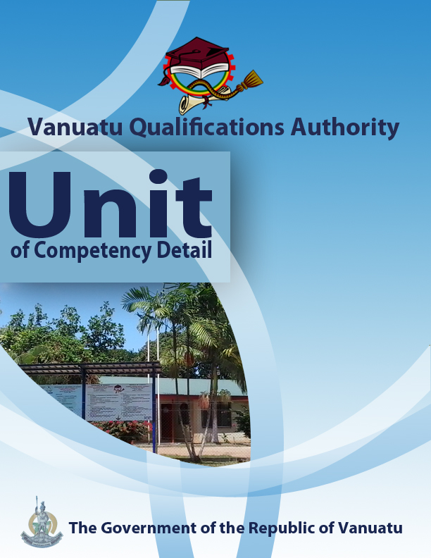

**CGCA0716**

**Demonstrate ways of adapting to climate change**

|  |  |
| --- | --- |
| **Level** | 1 |
| **Credit** | 5 |
| **Unit Descriptor** | This unit describes the performance outcomes, skills and knowledge required to assist a local community to develop appropriate measures for adapting to climate change. |
| **Pre-requisite** | CGHR0116, CGCK0216, CGCV0316, CGCC0416, CGCE0516, CGMC0616 |
| **Co – requisite** | Nil |
| **ELEMENT**   1. Demonstrate the need for adaptation strategies. 2. Illustrate appropriate adaptation measures. 3. Show that many measures include both adaptation and mitigation benefits. 4. Assist the development of adaptation and mitigation measures in a local community | **PERFORMANCE CRITERIA**   * 1. Evidence is provided to show that climate change is inevitable.   2. Justification is given for communities in Vanuatu to adopt adaptation measures to prepare for the impacts of climate change.   3. ***Adaptation techniques*** implemented by government, civil society and development organizations in Vanuatu are identified and demonstrated.   4. The importance of ***agroforestry*** is justified.   5. Traditional and modern methods of ***food preservation*** that can provide ***food security*** are identified and demonstrated.   6. Ways of protecting coral reefs, sea grass and mangrove ***ecosystems*** are identified.   7. The advantages of establishing a ***community conservation area*** are demonstrated.   8. ***Measures for ensuring household water security*** are identified.   9. Demonstration is given of the possible need for some settlements in Vanuatu to be relocated.   10. Other aspects of adaptation are discussed.   11. Examples of ***strategies*** ***that provide both mitigation and adaptation benefits*** are identified.   12. Roles played by women and men in climate change adaptation, and the barriers faced by each gender, are discussed.   13. Ways of ensuring that vulnerable people are included in the planning of community activities are discussed.   14. In consultation with the local community, a display of adaptation and mitigation measures that might be used in that community is prepared.   15. There is consultation with a local community about the adaptation and mitigation measures it might wish to adopt, and participation in their ***implementation.*** |
| **KEY COMPETENCIES/EMPLOYABILITY SKILLS AND EXAMPLES OF APPLICATION**   |  |  | | --- | --- | | **Required skills\*** | **Example of application** | | **Initiative** | Adapting to new situations • developing a strategic long-term vision • being creative • identifying opportunities not obvious to others • translating ideas into action • generating a range of options • initiating innovative solutions.   * *Work with a local community to help it develop appropriate measures to adapt to future climate change.* | | **Communication** | Verbal or non-verbal that includes: • speaking clearly and directly • writing to the needs of the audience • understanding the needs of internal and external parties • persuading effectively • establishing and using networks.   * *Present information both visually and verbally (using hand-drawn illustrations and technology) to explain the difference between greenhouse gas (GHG) mitigation and climate change adaptation, the importance of climate change adaptation measures in Vanuatu and appropriate climate change adaptation measures for communities in Vanuatu.* | | **Teamwork** | Working with people of different ages, gender, race, religion or political persuasion • working as an individual and as a member of a team • knowing how to define a role as part of a team • applying teamwork skills to a range of situations   * *Cooperate in a small group to deliver a meaningful presentation to people in the local area on climate change adaptation. Consult with this local community regarding appropriate measures to be undertaken.* | | **Information & Communication Technology** | Having a range of basic IT skills • applying IT as a management tool • using IT to organise data • being willing to learn new IT skills • having the occupational health and safety knowledge to apply technology • having the appropriate physical capacity   * *Use the internet to discover examples of adaptation strategies appropriate to the local area, Vanuatu and the Pacific region.* * *Use mobile phones for taking photographs of adaptation measures appropriate for the local area.* * *Use phones, email and social media to access information on adaptation and mitigation strategies.* | | **Problem solving** | Developing creative, innovative solutions • developing practical solutions • showing independence and initiative in identifying problems solving problems in teams • applying a range of strategies to problem solving • applying problem-solving strategies across a range of areas   * *Analyse features of a local area and determine how it will be affected by the impacts of future climate change, suggesting strategies for reducing the severity of these impacts.* | | **Self-management** | Having a personal vision and goals • evaluating and monitoring own performance • having knowledge and confidence in own ideas and vision • articulating own ideas and vision • taking responsibility   * *Reflect on knowledge and understanding of strategies to adapt to the impacts of climate change in Vanuatu.* * *Seek advice from others and be ready to express their own views on suitable mitigation and adaptation strategies for climate change.* | | **Planning** | Managing time and priorities – setting timelines, coordinating tasks • being resourceful • taking initiative and making decisions • establishing clear project goals and deliverables • allocating people and resources to tasks • participating in continuous improvement and planning • developing a vision and a proactive plan to accompany it.   * *Plan, collect, organize and analyse information on climate change adaptation measures that can be taken by individuals (both men and women) and communities in Vanuatu.* | | **Learning (gaining new skills and knowledge**) | Manage your own learning using a range of learning options suited to the individual learning style– mentoring, peer support, networking; • having enthusiasm for ongoing learning; • being willing to learn in any setting• being open to new ideas and techniques • being prepared to invest time and effort in learning new skills   * *Participate in group discussions to share knowledge and gain new skills and learning that will assist in community planning for strategies to adapt to the impacts of climate change.* | | **GESI (Gender Equity and Social Inclusion)** | Valuing and supporting women and disadvantaged persons and equal opportunity for all in workplaces and communities • mentoring younger people • valuing and respecting older people • respect of cultural, social, religious values and political persuasion differences   * *Ensure that discussions in the communities are inclusive of both male and female perspectives on strategies for adapting to the impacts of climate change* * *Ensure that planning and information on adaptation and mitigation strategies reflects cultural values and practices* |   * as per Provincial Skills Plan  **Required knowledge**   |  |  | | --- | --- | |  | * Awareness of some of the human actions that lead to increased amounts of GHGs in the atmosphere. * Understanding of how increased atmospheric GHG concentration will lead to global warming and climate change, and of how climate change is likely to affect the atmosphere and oceans. * Knowledge and experience of the impacts of climate change and of some of the measures already being taken to reduce the negative effects of these impacts * Knowledge of a local community, especially in terms of leadership structure, values, cultural and religious practices and livelihoods. | |  |  | | |

|  |  |  |
| --- | --- | --- |
| **RANGE STATEMENT**   |  | | --- | | The range statement relates to the unit of competency as a whole. It allows for different work environments and situations that may affect performance. **Bold italicised** wording, if used in the performance criteria, is detailed below. |   **Adaptation techniques**  may include:  Breeding new varieties of crops and animals, planting trees and vetiver grass, sustainable forest management and agroforestry, food preservation techniques, protection of coral reefs and mangroves, community conservation areas and marine reserves, non-destructive fishing techniques, better water security, relocation of buildings and settlements, promotion of renewable sources of energy, etc.  **Adaptation to climate change** refers to:  ways in which people adjust the way they live in order to cope with warmer temperatures and other climatic changes, reduce the harmful impacts of these changes, and take advantage of any benefits the changes may bring.  **Agroforestry** refers to:   * the planting of food crops and trees together on a plot of land.   **Community conservation area** refers to:   * an area where a village community decides to implement measures that will conserve its natural resources.   **Ecosystem** refers to:   * a group of plants and animals that live together and interact with each other and with the non-living elements of the environment around them. **Terrestrial ecosystems** are found on land and in freshwater streams, rivers and lakes, while **marine ecosystems** are found in coastal lagoons, tidal flats and the oceans.   **Food preservation** refers to:   * ways of preventing food or food crops from perishing or being destroyed by bacteria and other agencies.   **Food security** refers to:   * the ability of all people at all times to have access to sufficient, safe, nutritious food that enables them to maintain a healthy and active life.   **Implementation** can include:   * actions taken to make sure a decision or a measure is carried out.   **Mitigation of greenhouse gases** refers to:   * human actions to reduce the emissions of greenhouse gases (GHGs) or to increase the sinks (stores) of greenhouse gases.   **Measures for ensuring household water security** may include:   * establishing rainwater harvesting tanks, managing water use, fixing leaks and broken gutters, etc.   **Strategies that provide both mitigation and adaptation benefits** may include:   * composting and mulching, solar fruit drying, replanting mangroves, planting vetiver grass on slopes, using biogas, eating more root crops and vegetables, agroforestry, etc. | |
| **EVIDENCE GUIDE**  The evidence guide provides advice on assessment and must be read in conjunction with the performance criteria, required skills and knowledge, range statement and the Assessment Guidelines for the Training Package.  Critical aspects for assessment and evidence required to demonstrate competency in this unit  Evidence of the following knowledge, skills and attributes is essential:   * Knowledge and attributes of local communities and structures * Understanding of the features and elements of climate change, its causes and effects, and strategies for mitigation and adaptation. * Communication skills to develop individual and community awareness of the need to develop strategies for adapting to the impacts of climate change. * Skills and attributes in demonstrating at least one adaptation technique to others. * Understanding that some strategies provide benefits for both mitigation and adaptation. * Ability to interpret and construct diagrams, graphs and simple maps | **Context of Assessment**   * Assessment of underpinning knowledge and communication of ideas can be done in the classroom through observation and discussion. * Assessment of practical adaptation techniques across multiple sectors and of consultation with the local community regarding new adaptation measures to be introduced can be done in the field.   **Resource Implications**  Assessment process and resources must ensure:   * Physical access to communities to observe communications and/or collection of information and data * Checklists for the learner and assessor to guide community activities, communications and observations |
| **Assessment Methods**  Assessment methods must be chosen to ensure that knowledge of strategies for adapting to climate change can be practically demonstrated. Methods must include assessment of knowledge as well as assessment of practical skills, and may be done in conjunction with assessment of other units of competency. Allowance should be made for participants with disabilities. Some of the following examples are appropriate:   * Direct oral questioning combined with third party workplace or community reports of knowledge and performance by the learner. * Direct observation during community contact (may be undertaken during field visits and/or using technology such as phone/video) * Review of any written documentation evidencing knowledge and skills (maps, workbook activities) * Oral and/or written reflections by learners * Written holistic/summative assessment |