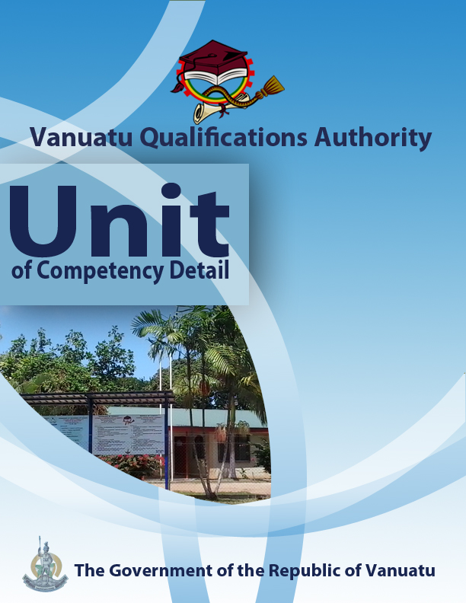

CGHV0116

Demonstrate ways in which communities are vulnerable to hazards and climate change

Level | 2
Credit | 6
Unit Descriptor | This unit describes the performance outcomes, skills and knowledge required to identify and explain how vulnerability to hazards and climate change depends on location and on access to assets of sustainable living.
Pre-requisite | CGHR0116, CGCK0216, CGCV0316, CGCC0416, CGCE0516, CGMC0616, CGCA0716
Co – requisite | Nil
ELEMENT  - Demonstrate the exposure of Pacific island countries to hazards, climate variability and climate change.  - Interpret variables affecting a community’s vulnerability to hazards and climate change.  - Identify impacts resulting from a community’s vulnerability to hazards and climate change.  - Evaluate a local community’s vulnerability to hazards and climate change.  - Apply knowledge to help a community become more aware of its vulnerability to hazards and climate change. | PERFOMANCE CRITERIA  - Natural and human-made hazards that affect the Pacific region are identified.  - The exposure of Pacific islands to the effects of climate variability and climate change is demonstrated.  - The terms vulnerability and resilience are differentiated.  - The ways in which different people have different vulnerabilities to hazards are demonstrated.  - The main assets of sustainable living and their effects on vulnerability are identified.  - Identification takes place of sectors, people and community assets that might be more vulnerable to hazards and climate change.  - Demonstration is given of the way that some communities in Vanuatu are more at risk than others.  3.1 Demonstration is provided of how the impacts of hazards and climate change are related to exposure and vulnerability.  3.2 The impacts of hazards and climate change on the natural landscape, ecosystems, fresh water resources, livelihoods, infrastructures and human life are identified.  3.3 Examples are provided of the impacts of climate change and hazards in Vanuatu.  4.1 A SWOT analysis of a community’s assets of sustainable living is conducted.  4.2 The community’s adaptive and coping capacity is assessed.  - The priorities of a community for improving its way of living are determined.  - The hazards and changes in climate that might affect these priorities are identified.  - Assistance is provided to a community to help it develop more resilience to hazards and climate change.
KEY COMPETENCIES/EMPLOYABILITY SKILLS AND EXAMPLES OF APPLICATION

Required skills* | Example of application
Initiative | Adapting to new situations • developing a strategic long-term vision • being creative • identifying opportunities not obvious to others • translating ideas into action • generating a range of options • initiating innovative solutions  - Initiate ways to consult with the local community on its vulnerability to hazards and future climatic change, its assets of sustainable living, its priorities for development, and the building of greater resilience (especially among the most vulnerable members of the community).
Communication | Verbal or non-verbal that includes: • speaking clearly and directly • writing to the needs of the audience • understanding the needs of internal and external parties • persuading effectively • establishing and using networks  - Present information both visually and verbally (using hand-drawn illustrations and technology) to explain the vulnerability of communities to the impacts of climate change in the local region (Vanuatu)  - Communicate personal experiences which demonstrate an understanding of the impacts of hazards and climate change in the local region.
Teamwork | Working with people of different ages, gender, race, religion or political persuasion • working as an individual and as a member of a team • knowing how to define a role as part of a team • applying teamwork skills to a range of situations  - Cooperate in a small group to conduct field investigations into vulnerability to hazards and climate change.  - Undertake activities and discussions in pairs and groups on concepts associated with vulnerability, resilience and the impacts of hazards and climate change.
Information & Communication Technology | Having a range of basic IT skills • applying IT as a management tool • using IT to organise data • being willing to learn new IT skills • having the occupational health and safety knowledge to apply technology • having the appropriate physical capacity  - Use the internet (optional) or printed resources to find examples of impacts of hazards and climate change in Vanuatu and the Pacific region  - Use mobile phones for taking photographs of examples of the impacts of hazards and climate change in the local area.  - Use phones, email and social media to access information on vulnerability to and impacts of climate change.  - Use computer applications to construct illustrations and graphical representations of data and information on vulnerability to and impacts of climate change.
Problem solving | Developing creative, innovative solutions • developing practical solutions • showing independence and initiative in identifying problems solving problems in teams • applying a range of strategies to problem solving • applying problem-solving strategies across a range of areas  - Determine why some people and some communities in Vanuatu are more at risk than others, and evaluate the vulnerability and adaptive/coping capacity of a local community.
Self-management | Having a personal vision and goals • evaluating and monitoring own performance • having knowledge and confidence in own ideas and vision • articulating own ideas and vision • taking responsibility  - Reflect on knowledge and understanding of how the impacts of hazards and climate change depend on vulnerability and exposure.  - Seek advice from others (through conversations and technology) and be ready to express their own views in discussions on individual and community vulnerability to climate change and the impacts of climate change.
Planning | Managing time and priorities – setting timelines, coordinating tasks • being resourceful • taking initiative and making decisions • establishing clear project goals and deliverables • allocating people and resources to tasks • participating in continuous improvement and planning • developing a vision and a proactive plan to accompany it.  - Plan, collect, organize and analyse information on the sectors, people and assets of a local community that might be more exposed to hazards and climate change, and on the community’s assets for sustainable living
Learning (gaining new skills and knowledge) | Manage your own learning using a range of learning options suited to the individual learning style– mentoring, peer support, networking; • having enthusiasm for ongoing learning; • being willing to learn in any setting• being open to new ideas and techniques • being prepared to invest time and effort in learning new skills  - Participate in group discussions to share new knowledge and engage in planning to help a community become more resilient to hazards and climate change.
GESI (Gender Equity and Social Inclusion) | Valuing and supporting women and disadvantaged persons and equal opportunity for all in workplaces and communities • mentoring younger people • valuing and respecting older people • respect of cultural, social, religious values and political persuasion differences  - Ensure that discussions in the communities are inclusive of both male and female perspectives on vulnerability and the impacts of hazards and climate change.  - Ensure that planning and information on vulnerability and the impacts of hazards and climate change reflects cultural aspects.
* as per Provincial Skills Plan

Required knowledge
- Knowledge and experience of the dynamics of a local community (leadership, decision-making, cultural and religious practices, cooperative activities, negative social forces, positive social forces, etc.)
- Knowledge and experience of climate change and hazards and their impacts
- Knowledge of the use of technological devices – phone, internet, email

RANGE STATEMENT

The range statement relates to the unit of competency as a whole. It allows for different work environments and situations that may affect performance. Bold italicised wording, if used in the performance criteria, is detailed below.

Adaptive capacity refers to:
- The ability of a community and systems to survive and cope with stresses brought about by climate change, and to take advantage of any opportunities that arise.

Assets or dimensions of sustainable living refer to:
- the different aspects of life that are needed to ensure that a community can develop in a healthy and productive manner, with all its members having equality of opportunities and rights. Five groups of assets are: natural, physical, human, financial and social.

Coping capacity refers to:
- the ability of a community and systems to face and manage adverse conditions, emergencies or disasters.

Ecosystem refers to:
- a group of plants and animals that live together and interact with each other and with the non-living elements of the environment around them. Terrestrial ecosystems are found on land and in freshwater streams, rivers and lakes, while marine ecosystems are found in coastal lagoons, tidal flats and the oceans. Examples of ecosystems found in Vanuatu include coral reefs, lowland tropical rain forests, secondary forests, high mountain forests, mangrove forests, savannah, grass fields, wetlands, beaches, tidal flats, and food gardens.

Exposure refers to:
- the way that people and assets are found in places that can be affected by hazards and climate change.

Hazard refers to:
- a dangerous phenomenon, substance, human activity or condition that may cause loss of life, injury or other health impacts, property damage, loss of livelihoods and services, social and economic disruption, or environmental damage.

Impacts or risks are:
- ways in which hazards and climate change affect natural ecosystems and human societies, often causing damage or destruction, but sometimes bringing benefits. Impacts are great when the vulnerability of people and communities is high, and not enough resilience has been developed.

Negative impacts are:
- the ways in which climate change and natural hazards cause damage and danger to ecosystems, human livelihoods and society.

Priorities are:
- the most important things or tasks that should be done first.

Resilience refers to:
- the ability of a person, household or community to cope with hazards, to prepare for hazards and climate change, and to recover from disasters that occur. Resilience is related to the assets of sustainable living mentioned above.

SWOT analysis refers to:
- an assessment of the strengths and weaknesses of a community and the opportunities and threats it may face.

Vulnerability includes:
- the degree to which life, property and/or the environment is open to being affected by, or unable to cope with, the adverse effects of hazards and changes in climate. The extent to which persons, families or communities are likely to suffer from a hazard or the effects of climate change because they lack the capacity to cope and adapt.

EVIDENCE GUIDE  The evidence guide provides advice on assessment and must be read in conjunction with the performance criteria, required skills and knowledge, range statement and the Assessment Guidelines for the Training Package.  Critical aspects for assessment and evidence required to demonstrate competency in this unit  Evidence of the following knowledge, skills and attributes is essential:  - Knowledge and attributes of local communities and structures  - Understanding of the vulnerability of communities and individuals to hazards and climate change, and how this affects the impacts.  - Knowledge and understanding of community strategies for reducing issues and risks arising from hazards and climate change.  - Effective communication with the local community to help it develop greater awareness of its vulnerability to hazards and future climatic changes.  - Interpretation and construction of diagrams, graphs and simple maps. |  | Context of Assessment  - Assessment of underpinning knowledge and communication of ideas can be done in the classroom through observation and discussion.  - Assessment of the SWOT analysis and consultations with the community can be done in the field or in the classroom.  Resource Implications  Assessment process and resources must ensure:  - Physical access to communities to observe communications and/or collection of information and data  - Checklists for the learner and assessor to guide community activities, communications and observations
Assessment Methods

Assessment methods must be chosen to ensure that knowledge of vulnerability to the impacts of hazards and climate change can be practically demonstrated. Methods must include assessment of knowledge as well as assessment of practical skills, and may be done in conjunction with assessment of other units of competency. Allowance should be made for participants with disabilities. Some of the following examples are appropriate:
- Direct oral questioning combined with third party workplace or community reports of knowledge and performance by the learner
- Direct observation during community contact (may be undertaken during field visits and/or using technology such as phone/video)
- Review of any written documentation evidencing knowledge and skills (maps, workbook activities)
- Oral and/or written reflections by learners
- Written holistic/summative assessment

