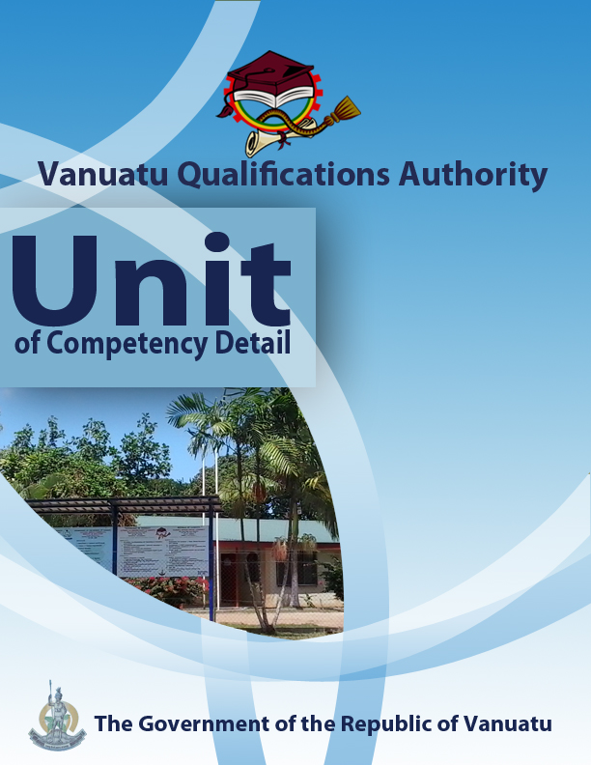

CGCR0216
Use traditional knowledge to build community resilience to disasters and climate change

Level | 2
Credit | 6
Unit Descriptor | This unit describes the performance outcomes, skills and knowledge required to use traditional techniques that foster community resilience to risks from hazards and climate change.
Pre-requisite | CGHR0116, CGCK0216, CGCV0316, CGCC0416, CGCE0516, CGMC0616, CGCA0716, CGHV0116.
Co – requisite | Nil
ELEMENT  - Demonstrate awareness of the terms traditional knowledge and resilience.  - Examine the challenges in gaining access to traditional knowledge.  - Examine ways in which traditional knowledge builds resilience to hazards and climate change  - Demonstrate traditional techniques that foster resilience.  - Promote the use of traditional knowledge in a local community. | PERFORMANCE CRITERIA  - The term traditional knowledge is used in the context of Vanuatu.  - The term resilience is used in relation to hazards and climate change.  - Reasons are suggested as to why traditional knowledge (TK) is disappearing in Vanuatu.  - Issues relating to the ownership and sharing of TK are examined.  - The types of traditional knowledge held by men and by women are differentiated.  - Possible ways are suggested for overcoming the challenges associated with TK.  - Examples of TK that help communities in Vanuatu to become more resilient to geological and hydro-meteorological hazards are provided.  - A traditional calendar for a local community is produced.  - Traditional techniques that build resilience to risks from hazards and climate change are demonstrated.  - Investigations are made into TK about hazards and climate change that already exists in a community.  - Owners of TK are consulted in order to find ways in which it can be used to promote greater resilience in the whole community.
KEY COMPETENCIES/EMPLOYABILITY SKILLS AND EXAMPLES OF APPLICATION

Required skills* | Example of application
Initiative | Adapting to new situations • developing a strategic long-term vision • being creative • identifying opportunities not obvious to others • translating ideas into action • generating a range of options • initiating innovative solutions  - Work with the local community to encourage a greater use of TK in reducing vulnerability to the impacts of disasters and climate change  - Use knowledge of TK to generate alternative and innovative ideas for reducing risks and vulnerability.  - Demonstrate at least one technique based on TK that can be used to promote greater resilience in the community
Communication | Verbal or non-verbal that includes: • speaking clearly and directly • writing to the needs of the audience • understanding the needs of internal and external parties • persuading effectively • establishing and using networks  - Present information both visually (using hand-drawn illustrations and technology) and verbally to individuals and groups on the challenges of gaining access to TK, on examples of different TK held by women and by men, and on examples of the use of TK in lessening vulnerability to hazards and climate change.
Teamwork | Working with people of different ages, gender, race, religion or political persuasion • working as an individual and as a member of a team • knowing how to define a role as part of a team • applying teamwork skills to a range of situations  - Work in a team to consult with owners of TK in the local community with a view to promoting a greater use of this TK in the community  - Undertake discussions and activities in pairs and groups regarding planning and findings related to fieldwork on TK in the community.
Information & Communication Technology | Having a range of basic IT skills • applying IT as a management tool • using IT to organise data • being willing to learn new IT skills • having the occupational health and safety knowledge to apply technology • having the appropriate physical capacity  - Use the internet and community/local area survey questionnaires to explore TK in Vanuatu.  - Use mobile phones for taking photographs of examples of TK used in local communities.  - Use phones, email and social media to access information on TK in local communities in Vanuatu.
Problem solving | Developing creative, innovative solutions • developing practical solutions • showing independence and initiative in identifying problems solving problems in teams • applying a range of strategies to problem solving • applying problem-solving strategies across a range of areas  - Devise suitable strategies for approaching owners of TK in the local community.  - Consult with owners of TK to find suitable ways in which traditional techniques can be used in the community to address vulnerability to hazards and climate change.
Self-management | Having a personal vision and goals • evaluating and monitoring own performance • having knowledge and confidence in own ideas and vision • articulating own ideas and vision • taking responsibility  - Reflect on knowledge and understanding of climate change, vulnerability, TK and community life in the local area.  - Seek advice from others and readily express own views in discussions that are based on personal experiences, in order to inform planning and learning about the use of traditional knowledge.
Planning | Managing time and priorities – setting timelines, coordinating tasks • being resourceful • taking initiative and making decisions • establishing clear project goals and deliverables • allocating people and resources to tasks • participating in continuous improvement and planning • developing a vision and a proactive plan to accompany it  - Plan the collection of information from a community about traditional knowledge and traditional techniques.  - Organise people, documents, transport and other variables in order to plan visits to communities to collect TK for the purpose of reducing vulnerability to hazards and climate change, and to help the community to implement at least one traditional technique.
Learning (gaining new skills and knowledge) | Managing your own learning using a range of learning options suited to the individual learning style– mentoring, peer support, networking; • having enthusiasm for ongoing learning; • being willing to learn in any setting• being open to new ideas and techniques • being prepared to invest time and effort in learning new skills  - Participate willingly in group discussions to share knowledge, and engage in planning to use TK within communities to assist them to better prepare for, and manage, vulnerability to disaster risks and climate change.
GESI (Gender Equity and Social Inclusion) | Valuing and supporting women and disadvantaged persons and equal opportunity for all in workplaces and communities • mentoring younger people • valuing and respecting older people • respect of cultural, social, religious values and political persuasion differences  - Ensure that discussions and field surveys in the communities are inclusive of both male and female perspectives on TK and vulnerability.  - Ensure that traditional knowledge is reflected in the implementation of practical techniques to reduce community vulnerability to disasters and the effects of climate change.
* as per Provincial Skills Plan

Required knowledge
- Knowledge and experience of the impacts of climate change and of some of the measures already being taken to reduce the negative effects of these impacts.
- Knowledge of a local community, especially in terms of leadership structure, cultural and religious practices and livelihoods.

RANGE STATEMENT

The range statement relates to the unit of competency as a whole. It allows for different work environments and situations that may affect performance. Bold italicised wording, if used in the performance criteria, is detailed below.

Climate change refers to:
- long-term continuous change in the climate or in the range of weather (e.g. more extreme events), measured over several decades, hundreds of years or millennia, and supported by statistical evidence

Geological hazards include:
- earthquakes, volcanic eruptions and tsunamis.
Hazard refers to:
- something natural or human-made that may cause disruption or damage to life, property and/or the environment

Hydro-meteorological hazards include:
- cyclones, storms, storm surges, king tides, intense rainfall events, floods, erosion, droughts and strong winds.

Resilience refers to:
- the ability of an individual, a household, a community or a nation to cope with hazards, to prepare for hazards and climate change, and to recover from disasters that occur.

Traditional calendar can refer to:
- a way of dividing up the year into months or seasons that guides the planning of agricultural activities. Such calendars have developed over hundreds or thousands of years and are often based on observations of changes in the environment. They vary from island to island, and for large islands, may be different in different areas of the island.

Traditional techniques can include:
- reading animal behavior and other natural weather/climate signs, food preservation, building design and construction, cultivation and fishing, protection from erosion on slopes, traditional taboos and traditional conservation areas.

Traditional knowledge (TK) refers to:
- information, observations, skills and understanding that has been passed orally from one generation to another for hundreds or thousands of years. It may be owned by one or more individuals, a community, a tribe, or a chief on behalf of the community or tribe. It is often secret and there are protocols involved in its transmission, e.g. the exchange of traditional items such as kava, mats and pigs. There are differences between the traditional knowledge held by women and the traditional knowledge held by men.

EVIDENCE GUIDE  The evidence guide provides advice on assessment and must be read in conjunction with the performance criteria, required skills and knowledge, range statement and the Assessment Guidelines for the Training Package.  Critical aspects for assessment and evidence required to demonstrate competency in this unit  Evidence of the following knowledge, skills and attributes is essential:  - Knowledge and attributes of local communities and traditional structures.  - Understanding of hazards, disasters, climate, climate change and resilience  - Knowledge and understanding of the use of traditional knowledge for reducing disaster risks and the impacts of climate change.  - Attributes and communication skills to develop individual and community awareness of the importance of traditional knowledge in reducing vulnerability to hazards and climate change.  - Demonstration of one technique based on TK that can be used to promote greater resilience in the community | Context of Assessment  - Assessment of underpinning knowledge and communication of ideas can be done in the classroom through observation and discussion.  - Assessment of practical applications of TK and of consultation with the local community regarding the use of TK should be done in the field.  Resource Implications  Assessment process and resources must ensure:  - Physical access to communities to observe communications and/or collection of information and data  - Checklists for the learner and assessor to guide community activities, communications and observation
Assessment Methods

Assessment methods must be chosen to ensure that awareness of the role of traditional knowledge in building community resilience to disasters and climate change can be practically demonstrated. Methods must include assessment of knowledge as well as assessment of practical skills, and may be done in conjunction with assessment of other units of competency. Allowance should be made for participants with disabilities. Some of the following examples are appropriate:
- Direct oral questioning combined with third party workplace or community reports of knowledge and performance by the learner
- Direct observation during community contact (may be undertaken during field visits and/or using technology such as phone/video)
- Review of any written documentation evidencing knowledge and skills (maps, workbook activities)
- Oral and/or written reflections by learners
- Written holistic/summative assessment

