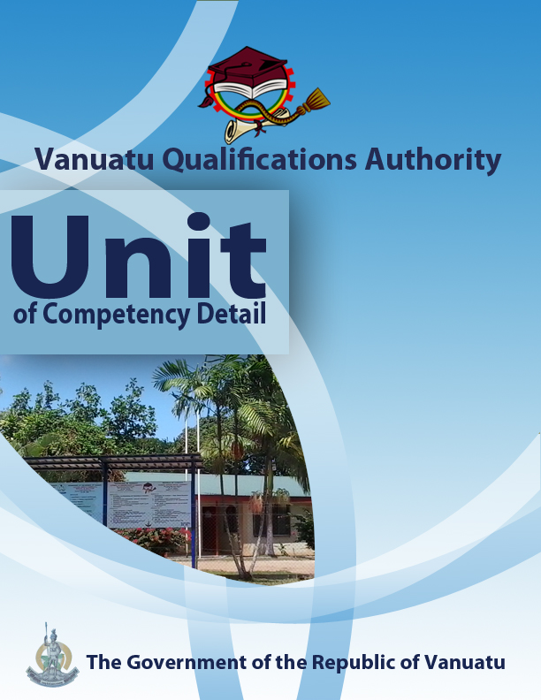

CGRM0316

Demonstrate knowledge of disaster risk reduction and climate change mitigation and adaptation
Level | 2
Credit | 3
Unit Descriptor | This unit describes the performance outcomes, skills and knowledge required to describe disaster reduction and climate change mitigation and adaptation.
Pre-requisite | CGHR0116, CGCK0216, CGCV0316, CGCC0416, CGCE0516, CGMC0616, CGCA0716, CGHV0116, CGCR0216.
Co – requisite | Nil
ELEMENT  - Outline common natural hazards.  - Demonstrate knowledge of disaster risk reduction.  - Apply the elements of disaster risk reduction to a real life disaster.  - Outline ways of preventing and mitigating disaster risks.  - Review measures for adapting to climate change and mitigating GHG emissions. | PERFORMANCE CRITERIA  - Common types of natural hazard in Vanuatu are stated, with an actual example provided for each.  - The term disaster risk reduction (DRR) is used in the context of Vanuatu.  - Knowledge of the main elements of DRR is demonstrated.  - Demonstration is provided of the application of the main elements of elements of DRR to a recent disaster  - Traditional measures that can reduce climate and disaster risks are identified.  - Modern methods used in Vanuatu for preventing and mitigating disaster risks are identified.  - Demonstration is given of skills and knowledge of appropriate measures for adapting to climate change and mitigating GHG emissions in Vanuatu.
KEY COMPETENCIES/EMPLOYABILITY SKILLS AND EXAMPLES OF APPLICATION

Required skills* | Example of application
Initiative | Adapting to new situations • developing a strategic long-term vision • being creative • identifying opportunities not obvious to others • translating ideas into action • generating a range of options • initiating innovative solutions  - Initiate and carry out enquiries into a recent disaster event in Vanuatu and the DRR measures that were taken.
Communication | Verbal or non-verbal that includes: • speaking clearly and directly • writing to the needs of the audience • understanding the needs of internal and external parties • persuading effectively • establishing and using networks  - Present information both visually (using hand-drawn illustrations and technology) and verbally to individuals and groups on traditional methods of preventing and mitigating disaster risks; the meaning of preparedness, response and recovery; and DRR in a recent natural event.
Teamwork | Working with people of different ages, gender, race, religion or political persuasion • working as an individual and as a member of a team • knowing how to define a role as part of a team • applying teamwork skills to a range of situations  - Work in a team to analyse DRR measures in a real life disaster.  - Work with another person to learn new techniques of adaptation and mitigation.
Information & Communication Technology | Having a range of basic IT skills • applying IT as a management tool • using IT to organise data • being willing to learn new IT skills • having the occupational health and safety knowledge to apply technology • having the appropriate physical capacity.  - Use the internet and community/local area survey questionnaires to access data on recent disasters affecting Vanuatu, the mitigation of disaster risks and adaptation to climate change.  - Use mobile phones for taking photographs of mitigation and adaptation strategies being used in the community.  - Use phones, email and social media to access information from NDMO, VMGD and other agencies concerned with disasters and climate change in Vanuatu.
Problem solving | Developing creative, innovative solutions • developing practical solutions • showing independence and initiative in identifying problems solving problems in teams • applying a range of strategies to problem solving • applying problem-solving strategies across a range of areas  - Work with each other to analyse risk maps on volcanic eruptions and cyclones.
Self-management | Having a personal vision and goals • evaluating and monitoring own performance • having knowledge and confidence in own ideas and vision • articulating own ideas and vision • taking responsibility  - Reflect on knowledge and understanding of disaster risk reduction and climate change mitigation and adaptation, ready to prepare for the development of appropriate needs-based action plans.
Planning | Managing time and priorities – setting timelines, coordinating tasks • being resourceful • taking initiative and making decisions • establishing clear project goals and deliverables • allocating people and resources to tasks • participating in continuous improvement and planning • developing a vision and a proactive plan to accompany it  - Devise plans for teaching a fellow learner about a technique of adaptation to climate change or mitigation of climate change.
Learning (gaining new skills and knowledge) | Managing your own learning using a range of learning options suited to the individual learning style– mentoring, peer support, networking; • having enthusiasm for ongoing learning; • being willing to learn in any setting• being open to new ideas and techniques • being prepared to invest time and effort in learning new skills  - Participate willingly in group discussions to share knowledge of strategies for disaster risk reduction, climate change mitigation, and climate change adaptation.
GESI (Gender Equity and Social Inclusion) | Valuing and supporting women and disadvantaged persons and equal opportunity for all in workplaces and communities • mentoring younger people • valuing and respecting older people • respect of cultural, social, religious values and political persuasion differences  - Ensure that discussions and practical work are inclusive of both male and female perspectives on the reduction of disaster risks and adaptation to climate change.  - Ensure that cultural and traditional knowledge is reflected in action plans for reducing community vulnerability to disasters and climate change.

* as per Provincial Skills Plan

Required knowledge
- Knowledge and experience of the impacts of climate change and of some of the measures already being taken to reduce the negative effects of these impacts.
- Knowledge of a local community, especially in terms of leadership structure, values, cultural and religious practices and livelihoods.
- Knowledge of the use of simple technological devices – phone, internet, email

RANGE STATEMENT

The range statement relates to the unit of competency as a whole. It allows for different work environments and situations that may affect performance. Bold italicised wording, if used in the performance criteria, is detailed below.

Disaster may include:
- cyclone, flood, volcanic eruption, earthquake, landslide, coastal inundation, fire, etc.

Disaster risks refer to::
- impacts on life, property and the environment that could happen if a hazard strikes a community.

Disaster Risk Reduction refers to:
- ways in which communities can prepare for disasters, as well as actions to take during and after the disaster event. The aim is to build community resilience to natural disasters.

Elements of disaster risk reduction (DRR) include:
- preparedness
- response
- recovery

Greenhouse gas (GHG) emissions refer to:
- gases such as carbon dioxide (CO₂), methane (CH₄) and nitrous oxide (N₂O) that are put into the atmosphere as a result of human activities

Modern methods can include:
- building design and location, relocation of villages, planting of mangroves, risk mapping, establishment of CDCCCs, awareness campaigns, consultation with local communities, advocating for funding, promoting of community coherence, etc.

Traditional measures may include:
- traditional calendars, traditional food gardens, traditional techniques of cultivation, animal husbandry, traditional methods of food preservation, reading weather patterns, traditional building designs, traditional taboos, traditional community support systems, protection from erosion.

EVIDENCE GUIDE  The evidence guide provides advice on assessment and must be read in conjunction with the performance criteria, required skills and knowledge, range statement and the Assessment Guidelines for the Training Package.  Critical aspects for assessment and evidence required to demonstrate competency in this unit  Evidence of the following knowledge, skills and attributes is essential:  - Knowledge and attributes of local communities and structures  - Knowledge of the main elements of disaster risk reduction and how to apply them to an actual disaster.  - Understanding of climate and climate change, and traditional and modern strategies for disaster risk reduction and adaptation to climate change.  - Attributes and communication skills to demonstrate strategies for climate change adaptation and mitigation to others. | Context of Assessment  - Assessment of underpinning knowledge and communication of ideas can be done in the classroom through observation and discussion.  - Assessment of consultations with the local community regarding action plans for DRR and CCA should be done in the field  Resource Implications  Assessment process and resources must ensure:  - Physical access to communities to observe communications and/or collection of information and data  - Checklists for the learner and assessor to guide community activities, communications and observations
Assessment Methods

Assessment methods must be chosen to ensure that knowledge of disaster risk reduction and climate change mitigation and adaptation procedures can be practically demonstrated. Methods must include assessment of knowledge as well as assessment of practical skills, and may be done in conjunction with assessment of other units of competency. Allowance should be made for participants with disabilities. Some of the following examples are appropriate:
- Direct oral questioning combined with third party workplace or community reports of knowledge and performance by the learner
- Direct observation during community contact (may be undertaken during field visits and/or using technology such as phone/video)
- Review of any written documentation evidencing knowledge and skills (maps, workbook activities)
- Oral and/or written reflections by learners
- Written holistic/summative assessment

