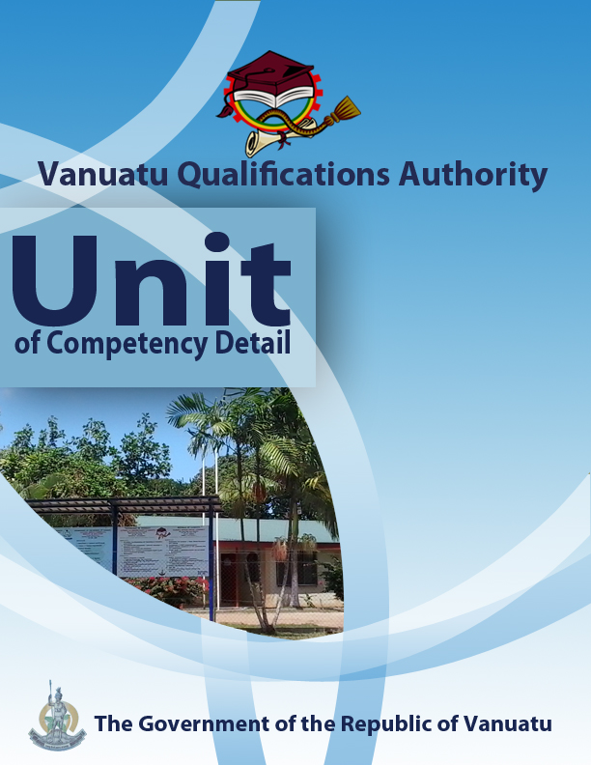

CGCA0416

Promote community action to prepare for climate change and disaster risk reduction
Level | 2
Credit | 3
Unit Descriptor | This unit describes the performance outcomes, skills and knowledge required to describe ways in which local communities can be assisted to prepare action plans for reducing risks from disasters and climate change.
Pre-requisite | CGHR0116, CGCK0216, CGCV0316, CGCC0416, CGCE0516, CGMC0616, CGCA0716, CGHV0116, CGCR0216, CGRM0316.
Co – requisite | Nil
ELEMENT  - Outline steps to mobilize communities for climate change adaptation and disaster risk reduction.  - Outline ways in which government agencies and NGOs can help communities to prepare for climate change and disaster risk reduction.  - Prepare action plans at local level for reducing risks from disasters and climate change | PERFORMANCE CRITERIA  - The primary roles and responsibilities of a Community Disaster and Climate Change Committee (CDCCC) are identified.  - Links between community, provincial and national agencies involved in climate change adaptation and disaster risk reduction are stated.  - The government agencies helping communities to prepare for climate change and disaster risk reduction are identified, and methods of contacting them are demonstrated.  - The various NGOs operating in Vanuatu that are helping communities to prepare for climate change and disaster risk reduction are identified, and methods of contacting them are demonstrated.  - There is discussion of the responsibilities and accountabilities of government agencies and NGOs in providing services to communities that enable them to adapt to hazards and climate change.  - Tools that help communities to prepare for climate change and disaster risk reduction are identified.  - Practical use is made of the key hazard messages promoted by government agencies and NGOs.  - An action plan is proposed to enable a local community to cope with disaster risks and the impacts of climate change  - Consultations take place with a local community in order to share, seek feedback on, and revise this proposed action plan.
KEY COMPETENCIES/EMPLOYABILITY SKILLS AND EXAMPLES OF APPLICATION

Required skills* | Example of application
Initiative | Adapting to new situations • developing a strategic long-term vision • being creative • identifying opportunities not obvious to others • translating ideas into action • generating a range of options • initiating innovative solutions  - Work with the local community to develop and/or monitor action plans for reducing vulnerability to disasters and the impacts of climate change.
Communication | Verbal or non-verbal that includes: • speaking clearly and directly • writing to the needs of the audience • understanding the needs of internal and external parties • persuading effectively • establishing and using networks  - Present information both visually (using hand-drawn illustrations and technology) and verbally to individuals and groups on key hazard messages promoted by CDCCCs, government and NGOs.
Teamwork | Working with people of different ages, gender, race, religion or political persuasion • working as an individual and as a member of a team • knowing how to define a role as part of a team • applying teamwork skills to a range of situations  - Work in a team to prepare a proposed action plan for a local community and consult on this with representatives of the local community, including both men and women.  - Undertake discussions and activities in pairs and groups regarding planning and information related to community strategies for disaster risk reduction and adaptation to climate change.
Information & Communication Technology | Having a range of basic IT skills • applying IT as a management tool • using IT to organise data • being willing to learn new IT skills • having the occupational health and safety knowledge to apply technology • having the appropriate physical capacity.  - Use the internet and community/local area survey questionnaires to access data on the mitigation of disaster risks and adaptation to climate change.  - Use phones, email and social media to access information from NDMO, VMGD and other agencies concerned with disasters and climate change in Vanuatu.
Problem solving | Developing creative, innovative solutions • developing practical solutions • showing independence and initiative in identifying problems solving problems in teams • applying a range of strategies to problem solving • applying problem-solving strategies across a range of areas  - Work with each other and the local community to devise a suitable action plan for reducing risks from disasters and adapting to climate change  - Devise strategies for implementing community plans to reduce risks from disasters and adapt to climate change.
Self-management | Having a personal vision and goals • evaluating and monitoring own performance • having knowledge and confidence in own ideas and vision • articulating own ideas and vision • taking responsibility  - Reflect on knowledge and understanding of climate change, vulnerability, TK and local community life in order to inform the development of appropriate needs-based action plans.  - Seek advice from others and readily express own views in discussions that are based on personal experiences, in order to inform planning and learning about disaster risk reduction at a community level.
Planning | Managing time and priorities – setting timelines, coordinating tasks • being resourceful • taking initiative and making decisions • establishing clear project goals and deliverables • allocating people and resources to tasks • participating in continuous improvement and planning • developing a vision and a proactive plan to accompany it  - Devise an action plan for helping a community to reduce risks from disasters and adapt to climate change.  - Organise people, documents, transport and other variables in order to plan visits to communities to help them formulate and implement/monitor lines of action for developing greater resilience to disasters and climate change.
Learning (gaining new skills and knowledge) | Managing your own learning using a range of learning options suited to the individual learning style– mentoring, peer support, networking; • having enthusiasm for ongoing learning; • being willing to learn in any setting• being open to new ideas and techniques • being prepared to invest time and effort in learning new skills  - Participate willingly in group discussions to share knowledge and engage in planning to prepare action plans to help communities to better prepare for, and manage, vulnerability to disaster risks and climate change.
GESI (Gender Equity and Social Inclusion) | Valuing and supporting women and disadvantaged persons and equal opportunity for all in workplaces and communities • mentoring younger people • valuing and respecting older people • respect of cultural, social, religious values and political persuasion differences  - Ensure that discussions and practical work in the communities are inclusive of both male and female perspectives on plans for reducing disaster risks and adapting to climate change.  - Ensure that cultural and traditional knowledge is reflected in action plans for reducing community vulnerability to disasters and climate change.
* as per Provincial Skills Plan

Required knowledge
- Knowledge and experience of the impacts of climate change and of some of the measures already being taken to reduce the negative effects of these impacts.
- Knowledge of a local community, especially in terms of leadership structure, culture, values and religious practices and livelihoods.
- Knowledge of the use of simple technological devices – phone, internet, email

RANGE STATEMENT

The range statement relates to the unit of competency as a whole. It allows for different work environments and situations that may affect performance. Bold italicised wording, if used in the performance criteria, is detailed below.

An action plan refers to:
- actions to be taken in the community to reduce the risks of natural disasters and climate change. These actions are prioritized, with the most important to be done first.

Community Disaster and Climate Change Committees (CDCCCs) are:
- committees established by community leaders to help a community prepare for disasters and climate change, look after people during and after the actual hazard, and report damage to Area Councils, Provincial Governments and the NDMO.

Community, provincial and national agencies include:
- CDCCCs, Provincial Disaster & Climate Change Committees, the National Disaster Management Office and the National Advisory Board on Climate Change and Disaster Risk Reduction.

Disaster may include:
- cyclone, flood, volcanic eruption, earthquake, landslide, coastal inundation, fire, etc.

Disaster risks refer to::
- impacts on life, property and the environment that could happen if a hazard strikes a community.

Disaster Risk Reduction refers to:
- ways in which communities can prepare for disasters, as well as actions to take during and after the disaster event. The aim is to build community resilience to natural disasters.

Government agencies may include:
- National Advisory Board on Climate Change and Disaster Risk Reduction (NAB), Vanuatu Meteorological and Geo-hazards Department (VMGD), National Disaster Management Office (NDMO), Department of Agriculture and Rural Development (DARD), Department of the Environment, Department of Tourism, Public Works Department (PWD), University of the South Pacific (USP), United Nations Development Programme (UNDP), South Pacific Regional Environment Programme (SPREP), aid-donor and development agencies such as United States Aid (USAID), Secretariat of the Pacific Community / Deutsche Gesellschaft für Internationale Zusammenarbait GmbH Coping with Climate Change in the Pacific Island Region (SPC/GIZ CCCPIR), European Union Pacific Technical and Vocational Education and Training (EU PacTVET), etc.

Impacts of climate change may include:
- sea level rise, loss of biodiversity, increased number of extreme weather events, degradation of coral reefs, increased urban migration, etc.

Key hazard messages consist of
- advice and instructions given to the public on actions to be taken before, during and after a natural disaster.

Non-government organizations (NGOs) may include:
- Vanuatu Non-Governments Association (VANGO), Red Cross, Care International, Save the Children, Oxfam, Adventist Development Relief Agency(ADRA), Live and Learn, Wan Smolbag, etc.

Tools helping communities to prepare for climate change include:
- Mobile phones, the NAB portal, NDMO/VMGD sms early alert system and other technologies

EVIDENCE GUIDE  The evidence guide provides advice on assessment and must be read in conjunction with the performance criteria, required skills and knowledge, range statement and the Assessment Guidelines for the Training Package.  Critical aspects for assessment and evidence required to demonstrate competency in this unit  Evidence of the following knowledge, skills and attributes is essential:  - Knowledge and attributes of local communities and structures  - Knowledge of action plans for reducing community vulnerability to disaster risks and adapting to climate change.  - Understanding of climate and climate change, and traditional and modern strategies for disaster risk reduction and adaptation to climate change.  - Attributes and communication skills to develop community action plans for climate change adaptation and disaster risk reduction | Context of Assessment  - Assessment of underpinning knowledge and communication of ideas can be done in the classroom through observation and discussion.  - Assessment of consultations with the local community regarding action plans for DRR and CCA should be done in the field  Resource Implications  Assessment process and resources must ensure:  - Physical access to communities to observe communications and/or collection of information and data  - Checklists for the learner and assessor to guide community activities, communications and observations
Assessment Methods

Assessment methods must be chosen to ensure that promoting community action for climate change adaptation and disaster risk reduction can be practically demonstrated. Methods must include assessment of knowledge as well as assessment of practical skills, and may be done in conjunction with assessment of other units of competency. Allowance should be made for participants with disabilities. Some of the following examples are appropriate:
- Direct oral questioning combined with third party workplace or community reports of knowledge and performance by the learner
- Direct observation during community contact (may be undertaken during field visits and/or using technology such as phone/video)
- Review of any written documentation evidencing knowledge and skills (maps, workbook activities)
- Oral and/or written reflections by learners
- Written holistic/summative assessment

